|  |  |
| --- | --- |
| Date | 24 June 2025 |
| Team ID | LTVIP2025TMID20421 |
| Project Name | Streamlining Ticket Assignment For Efficient Support Operations |
| Mentor Name | Dr Shaik Salma Begum |
| Maximum Marks | 10 Marks |

Streamlining Ticket Assignment For Efficient Support Operations

**Milestone 1: Setting Up ServiceNow Instance:**

* Sign up on [developer.servicenow.com](https://developer.servicenow.com) and create a developer account.
* Navigate to the Personal Developer Instance section and request a new instance.
* Fill out the required information and submit the request.
* Instance details (URL, username, password) will be sent via email.
* Log in to the instance using the provided credentials.
* The instance is ready for development and customization.

**Milestone 2: Creating Users:**

* Open ServiceNow by logging into your instance.
* In the left-hand navigation pane, click on "All" to expand the application list.
* In the filter search bar, type "Users" and select "Users" under the System Security module.
* Click on the "New" button to begin creating a new user.
* In the form that appears, fill in the necessary details such as User ID, First Name, Last Name, and Email.

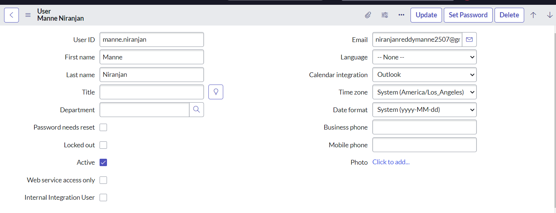

* After completing the form, click on "Submit" to save the new user.
* To create another user, click on the "New" button again.
* Enter the required information for the second user in the same manner.

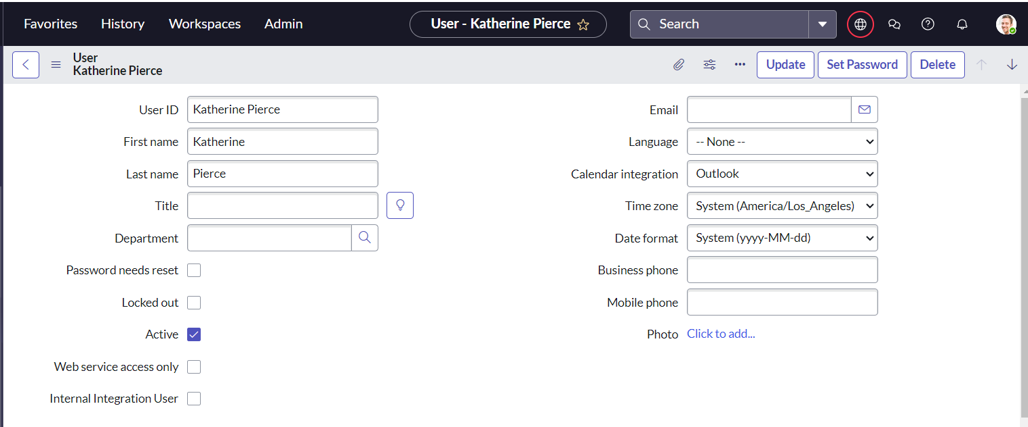

* Once all fields are filled, click on "Submit" to add the second user to the system.

**Milestone 3: Creating Groups:**

* Open ServiceNow by logging into your instance.
* Click on "All" in the left-hand navigation panel to expand the application menu.
* In the filter search bar, type "Groups" and select "Groups" under the System Security module.
* Click on the "New" button to create a new group.
* In the form that appears, fill in the required details such as the Group Name and Description. 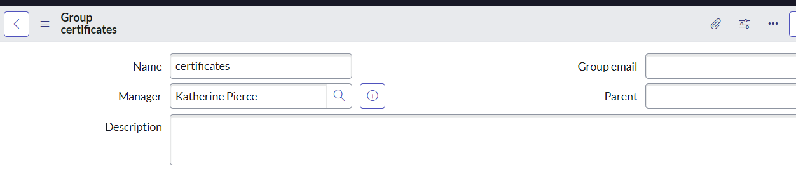
* Once the details are entered, click on "Submit" to save the group.
* To create another group, click on the "New" button again.
* Fill in the necessary details for the second group, just as you did for the first one.

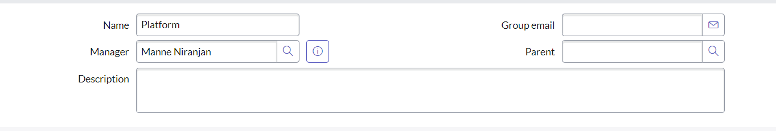

* After completing the form, click on "Submit" to save the second group.

**Milestone 4: Creating Roles:**

* Open ServiceNow by logging into your instance.
* Click on "All" in the left-hand navigation pane to expand the application modules.
* In the filter search bar, type "Roles" and select "Roles" under the System Security section.
* Click on the "New" button to begin creating a new role.
* In the form that appears, fill in the necessary details such as the Role Name and Description.

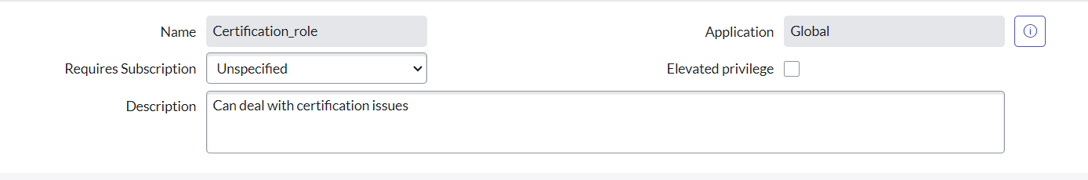

* After entering all the required information, click on "Submit" to save the new role.
* To create another role, click on the "New" button once more.
* Enter the relevant details for the second role in the form provided.

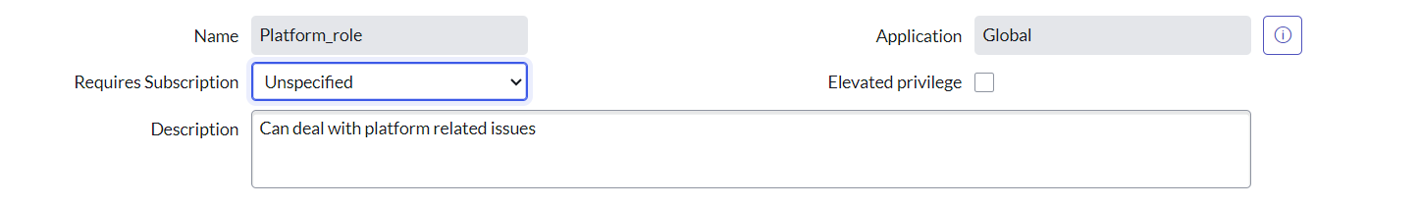

* Once completed, click on "Submit" to save the second role.

**Milestone 5: Creating Table:**

* Open ServiceNow by logging into your instance.
* Click on "All" in the left-hand navigation pane to expand the application modules.
* In the filter search bar, type "Tables" and select "Tables" under the System Definition section.
* Click on the "New" button to begin creating a new table.
* In the form that appears, enter the Label as "Operations related".
* Check the boxes for "Create module" and "Create mobile module" to generate the respective modules automatically.
* Under the New Menu Name, enter "Operations related" to define where the module will appear.
* In the Table Columns section, define the required fields for your table.

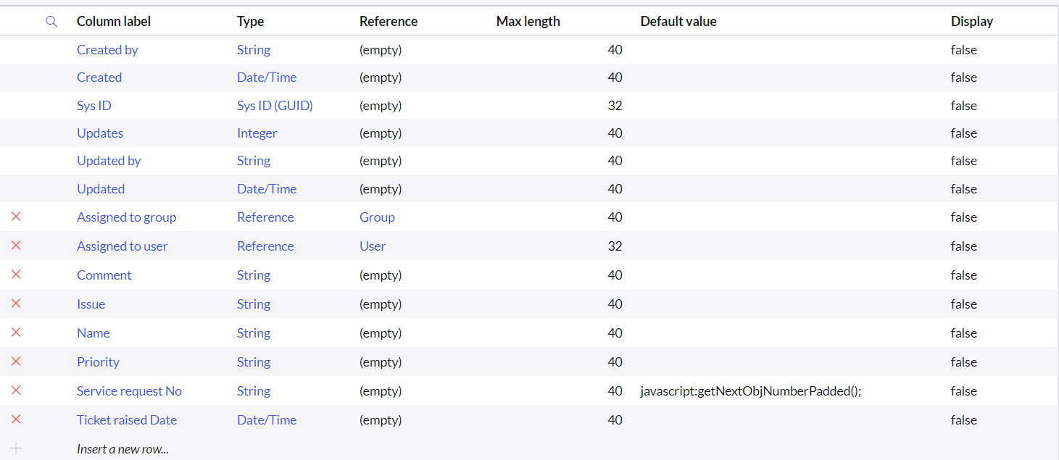

* After completing the form, click on "Submit" to save the table.
* **Create Choices for the Issue Field**
  1. Open the newly created table using **Form Design**.
  2. Locate the field labeled **"Issue"** or create a new field if it doesn't exist.
  3. Change the field type to **Choice** to allow multiple options.
  4. Add the following choices under this field:
     1. **Unable to login to platform**
     2. **404 error**
     3. **Regarding certificates**
     4. **Regarding user expired**
  5. Save the form to apply the changes.

**Milestone 6: Assign roles & users to groups:**

**Assign Roles & Users to Certificate Group**

* Open ServiceNow and log into your instance.
* Click on "All" in the left-hand navigation panel to expand the application modules.
* In the filter search bar, type "Groups" and select "Groups" under the System Security section.
* From the list of available groups, select the group named "Certificates".
* Under the Group Members related list, click on the "Edit" button.
* In the user selection window, search for "Katherine Pierce", select her name, and click on "Save" to add her to the group.
* Next, navigate to the Roles related list within the same Certificates group form.
* Click on the "Edit" button under the Roles section.
* Search for "Certification_role", select it, and click "Save" to assign the role to the group.

**Assign Roles & Users to Platform Group**

* Open **ServiceNow** and log into your instance.
* Click on **"All"** in the left-hand navigation panel to expand the application modules.
* In the filter search bar, type **"Groups"** and select **"Groups"** under the **System Security** section.
* From the list of groups, select the group named **"Platform"**.
* Scroll down to the **Group Members** related list and click on the **"Edit"** button.
* In the user selection window, search for **"Manne Niranjan"**, select the user, and click on **"Save"** to add them to the group.
* Now scroll to the **Roles** related list within the Platform group form and click on the **"Edit"** button.
* In the role selection window, search for **"Platform_role"**, select the role, and click on **"Save"** to assign it to the group.

**Milestone 7: Assign Role to Table:**

* Open **ServiceNow** and log into your instance.
* Click on **"All"** in the left-hand navigation pane to expand the application menu.
* In the filter search bar, type **"Tables"** and select the **"Tables"** option under **System Definition**.
* From the list of tables, select the table named **"Operations related"**.
* In the table record, scroll down and click on the **"Application Access"** tab.
* In the list of access controls, click on the **u_operations_related Read** operation to open its configuration.
* Now, click on the **profile icon** in the top-right corner of the screen.
* Select **"Elevate Role"** from the dropdown.
* Choose **"security_admin"** and click on **"Update"** to elevate your privileges.
* Back in the Read operation form, scroll down to the **"Requires role"** section.
* Double-click inside the field to insert a new row.
* Enter **"platform_role"** as the first role and **"certificate_role"** as the second role.
* Click on **"Update"** to save the changes to the Read access control.

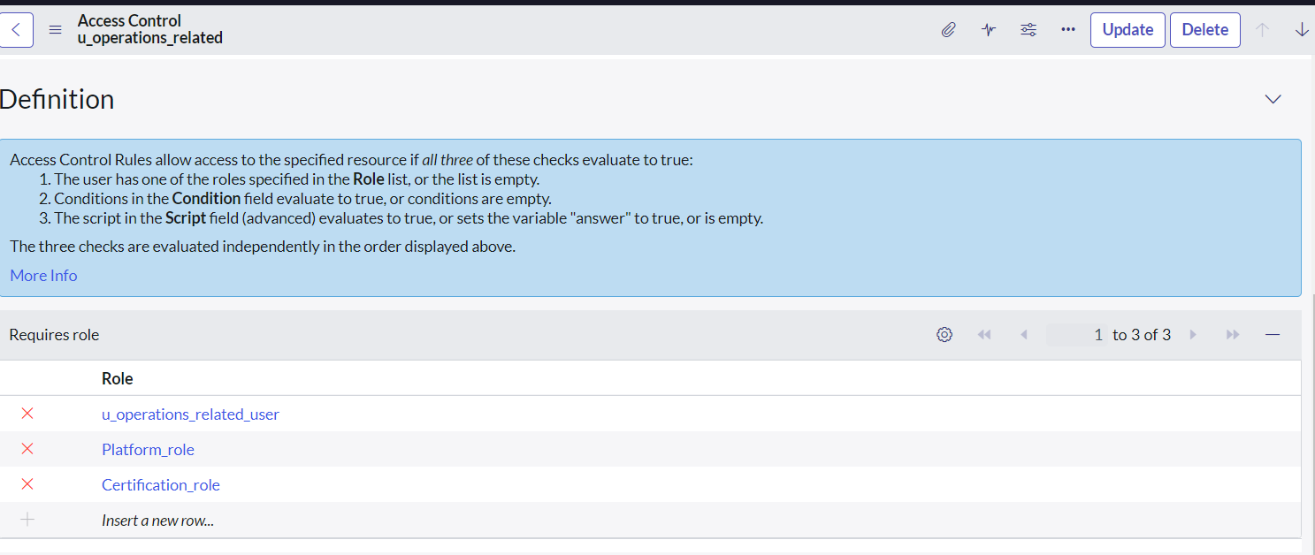

* Now, return to the access list and click on the **u_operations_related Write** operation.
* In the **Requires role** section, double-click to insert new rows.
* Again, enter **"platform_role"** and **"certificate_role"** as required roles.
* Click on **"Update"** to save the Write access control.

**Milestone 8: Create ACL (Access Control List):**

* Open ServiceNow and log into your instance.
* Click on "All" in the left-hand navigation pane to expand the application modules.
* In the filter search bar, type "ACL" and select "Access Control (ACL)" under the System Security section.
* Click on the "New" button to create a new access control rule.
* In the form that appears, fill in the necessary details such as:
  1. Type: record
  2. Operation: read / write / create / delete (as applicable)
  3. Name: Select the appropriate table, e.g., u_operations_related or its fields

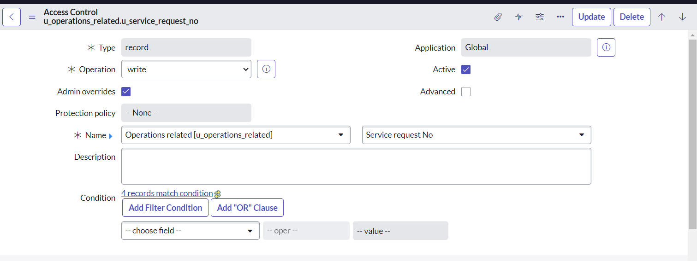

* Scroll down to the "Requires role" section.
* Double-click inside the empty field to insert a new row.
* Enter the role name admin to give administrative access.
* Click on "Submit" to save the ACL rule.

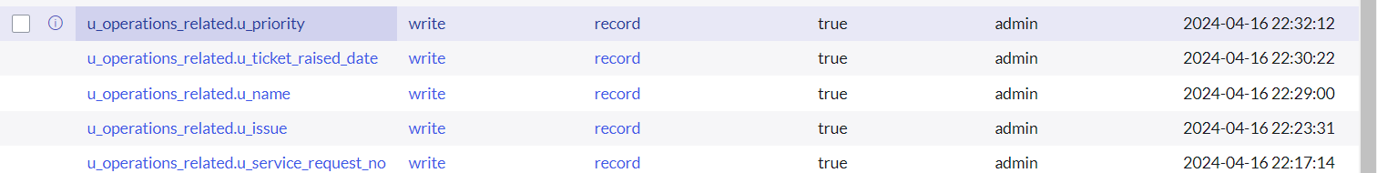

**Milestone 9: Creating A Flow:**

**Create a Flow to Assign Operations Ticket to Group:**

* Open ServiceNow and log into your instance.
* Click on "All" in the left-hand navigation pane to expand the application modules.
* In the filter search bar, type "Flow Designer" and select "Flow Designer" under the Process Automation section.

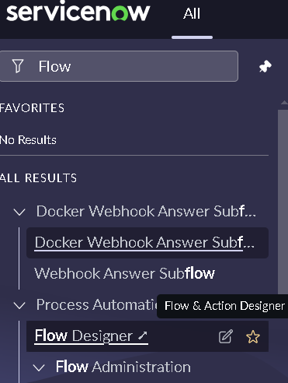

* Once the Flow Designer opens, click on the "New" button and select "Flow" to create a new flow.

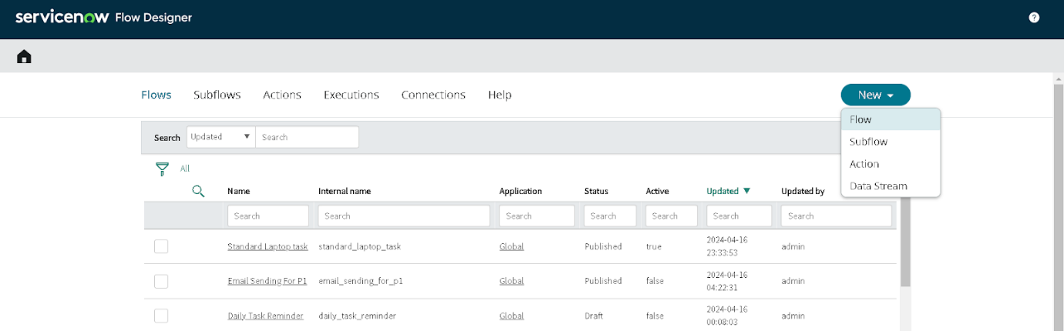

* Under the Flow Properties, enter the Flow Name as “Regarding Certificate”.
* Ensure the Application is set to Global.
* Set the Run As User to System User from the available choices.

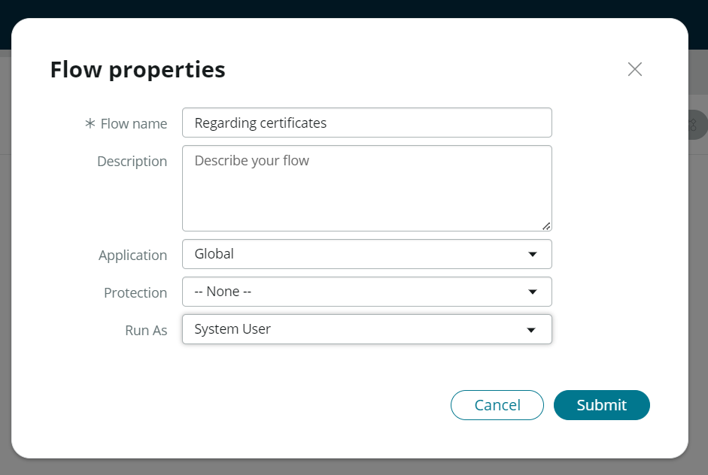

* Click on Submit to create the flow.

=>Add a Trigger

* Click on "Add a Trigger" to begin defining the event that will start the flow.
* In the trigger selection menu, search for "Create or Update Record" and select it.
* For the Table Name, choose “Operations related”.
* Set the Condition as follows:  
   • Field: *Issue*  
   • Operator: *is*  
   • Value: *Regarding Certificates*

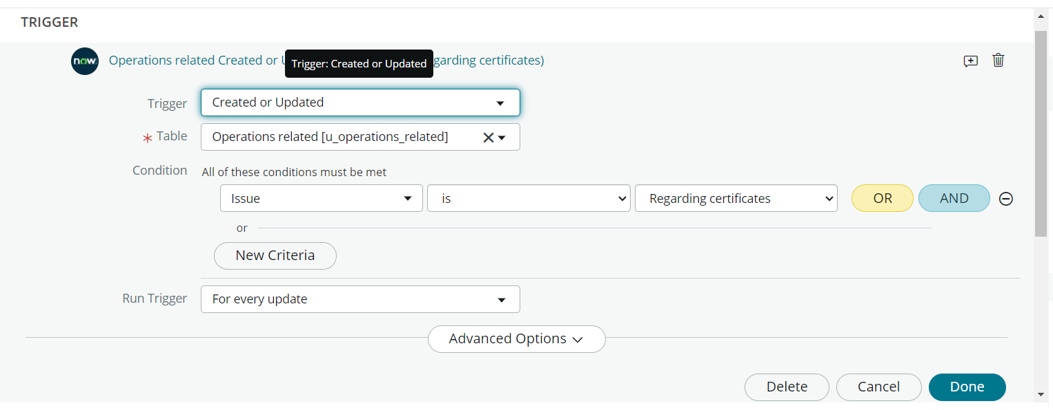

* Click on Done to save the trigger.

=>Add an Action

* Now under Actions, click on "Add an Action".
* In the action selection menu, search for and select "Update Record".
* In the Record field, drag and drop the record data from the Data panel on the left-hand side.
* The Table field will automatically populate based on the trigger.
* Under Fields, choose “Assigned to Group”.
* Set its Value to “Certificates”.

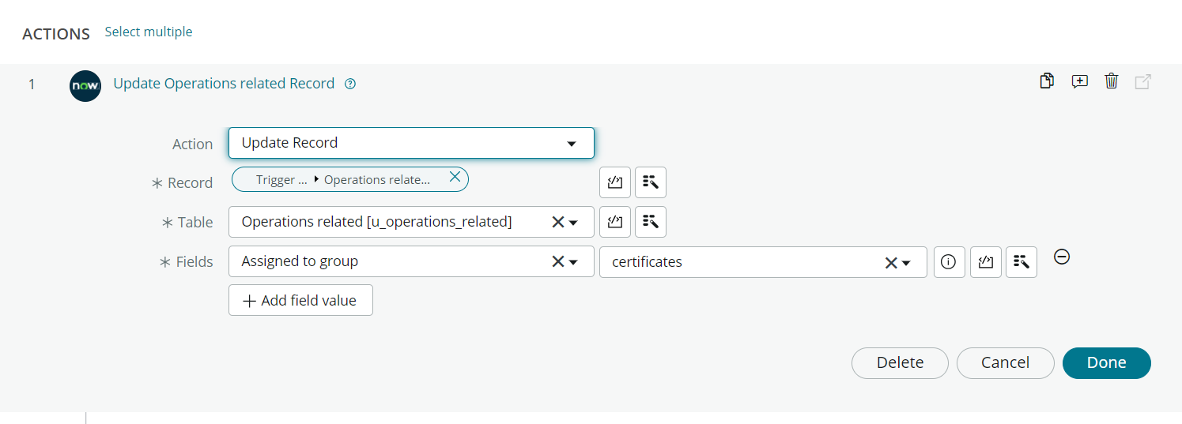

* Click on Done to complete the action.

=>Final Steps

* Click on Save to save your flow.
* Click on Activate to enable the flow so it automatically runs when the specified condition is met.

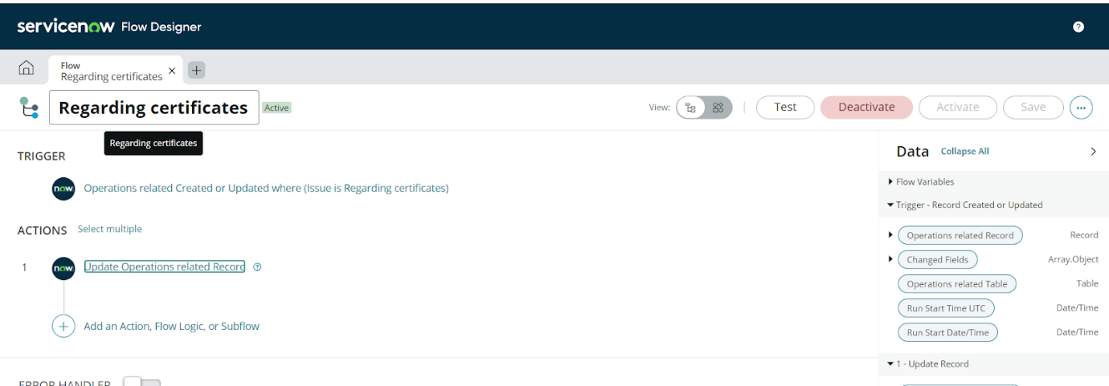

**Create a Flow to Assign Operations Ticket to Platform Group:**

* Open ServiceNow and log into your instance.
* Click on "All" in the left-hand navigation panel to expand the application modules.
* In the filter search bar, type "Flow Designer" and select "Flow Designer" under the Process Automation section.
* After Flow Designer opens, click on the "New" button and choose "Flow" to create a new flow.
* In the Flow Properties window, enter the Flow Name as “Regarding Platform”.
* Ensure that the Application is set to Global.
* For the Run As User, select System User from the dropdown list.
* Click on Submit to create and open the flow.

=>Add a Trigger

* Click on "Add a Trigger" to define the event that will activate the flow.
* In the trigger type selection, search for and choose "Create or Update Record".
* In the Table Name field, select "Operations related".
* Set the following Condition:  
   • Field: *Issue*  
   • Operator: *is*  
   • Value: *Unable to login to platform*
* Click on "New Criteria" to add another condition.  
   • Field: *Issue*  
   • Operator: *is*  
   • Value: *404 Error*
* Click on "New Criteria" again to add the third condition.  
   • Field: *Issue*  
   • Operator: *is*  
   • Value: *Regarding User expired*
* After all criteria are added, click on Done to save the trigger.

=>Add an Action

* Under Actions, click on "Add an Action".
* In the action type selection, search for and select "Update Record".
* In the Record field, drag the record variable from the Data panel on the left-hand side.
* The Table field will be auto-populated as Operations related.
* Under Fields, select "Assigned to group".
* Set the value to "Platform" to route the ticket to the appropriate group.
* Click on Done to save the action.

=>Final Steps

* Click on Save to save the flow configuration.
* Click on Activate to enable the flow so it will run automatically when the specified issue conditions are met.

**Conclusion:**

The implementation of the automated ticket routing system at ABC Corporation has proven to be a significant success. By leveraging the robust features of ServiceNow, the project team was able to eliminate the inefficiencies of manual ticket assignment and replace them with a streamlined, rule-based automation process. This transformation has resulted in faster ticket resolution times, improved workload distribution among support teams, and better adherence to SLA commitments. Moreover, the system ensures that tickets are routed based on issue type, which enhances the accuracy and efficiency of support operations. Overall, this initiative not only increased operational efficiency but also contributed to a more organized and responsive IT support environment within the organization.